Project Design Phase
Solution Architecture

Date | 20-02-2026
Team ID | LTVIP2026TMIDS24565
Project Name | Electric Motor Temperature Prediction Using Meachine Learning
Maximum Marks | 4 Marks

Solution Architecture:
Electric Motor Temperature Prediction System
Solution architecture in this project bridges the gap between the business problem of electric motor overheating and the technological solution using machine learning and web deployment. It defines how the system components interact to provide accurate, real-time motor temperature prediction for predictive maintenance.
The goal of this solution architecture is to design a structured, scalable, and efficient system that enables industrial operators and maintenance engineers to prevent unexpected motor failures.

Example - Solution Architecture Diagram:

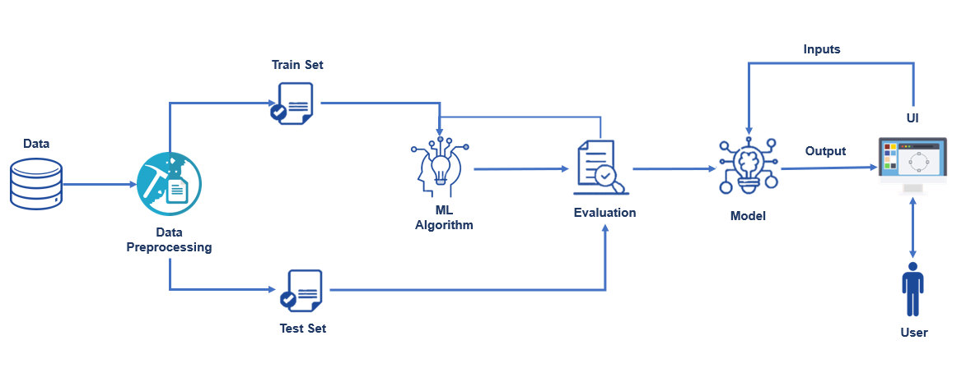
Figure 1: Architecture and data flow of the Electric Motor Temperature Prediction
Reference: https://aws.amazon.com/blogs/industries/voice-applications-in-clinical-research-powered-by-ai-on-aws-part-1-architecture-and-design-considerations/

